ADITYA UNIVERSITY
Surampalem
Department of AIML
DBMS CAPSTONE PROJECT
Project Documentation Report

Project Title: E-Commerce Order Management System.

Submitted by:
S. No |  | Student Name | Roll Number
1 | G. SPANDANA |  | 25B11AI340
2 | K. PAVANI |  | 25B11AID17
3 | N. SITA MAHALAKSHMI |  | 25B11AI845
4 | P. RISHITHA |  | 25B11AI940
Course: Database Management Systems (DBMS) Course Code:
Faculty Coordinator:
Academic Year: 2026 Date of Submission:
GitHub Repository Link:

TABLE OF CONTENTS
(This table updates automatically when the document is opened in Microsoft Word. If it appears empty, right-click it and choose "Update Field".)
TABLE OF CONTENTS ............................................................................................................................................. 1
- ABSTRACT .............................................................................................................................................................. 1
- INTRODUCTION .................................................................................................................................................... 1
  - Background ......................................................................................................................................................... 1
  - Purpose of the Database .................................................................................................................................... 1
- PROBLEM STATEMENT ..................................................................................................................................... 1
- OBJECTIVES .......................................................................................................................................................... 1
- TOOLS & TECHNOLOGIES USED .................................................................................................................... 1
- DATABASE DESIGN .............................................................................................................................................. 1
  - Identified Entities ............................................................................................................................................... 1
  - Entity Attributes................................................................................................................................................. 1
  - ER Diagram ........................................................................................................................................................ 1
  - Relationships & Cardinality.............................................................................................................................. 1
  - Relational Database Schema ............................................................................................................................. 1
  - Normalization ..................................................................................................................................................... 1
- DATABASE IMPLEMENTATION ....................................................................................................................... 1
  - DDL — Database and Table Creation ............................................................................................................. 1
  - Sample Data — DML......................................................................................................................................... 1
  - Constraints & Data Integrity ............................................................................................................................ 1
  - SQL Operations & Queries ............................................................................................................................... 1
  - Sample Outputs / Screenshots ........................................................................................................................... 1
- MODULES & FUNCTIONALITIES ..................................................................................................................... 1
- GITHUB REPOSITORY & TEAM RESPONSIBILITIES ................................................................................ 1
- ENHANCEMENTS & FUTURE IMPROVEMENTS ....................................................................................... 1
- CONCLUSION ....................................................................................................................................................... 1
- REFERENCES ....................................................................................................................................................... 1
APPENDIX ................................................................................................................................................................... 1
- Complete SQL Script .......................................................................................................................................... 1
- Additional Screenshots / Outputs....................................................................................................................... 1

- ABSTRACT
The E-Commerce Order Management System is a centralized database architecture designed to manage the entire transactional lifecycle of digital marketplace workflows. The platform handles core business data entities, including customers, multi-destination delivery addresses, product categories, store products, customer orders, granular order items, and payment transaction logs.
This project isolates and resolves standard back-end problems found in unorganized flat-file or spreadsheet management frameworks, such as duplicate records, inventory inconsistencies, delayed order status updates, and extreme latencies when retrieving historical order summaries.
The database schema is engineered using the Entity-Relationship (ER) model and mapped into a production-ready relational structure using primary and foreign key constraints. Relational optimization up to the Third Normal Form (3NF) is strictly implemented to drastically reduce data redundancies and prevent update, insertion, or deletion anomalies. To safeguard transaction data validation at the storage layer, essential integrity constraints—including PRIMARY KEY, FOREIGN KEY, NOT NULL, UNIQUE, and CHECK configurations—are embedded directly into the layout.
Ultimately, this project applies fundamental Database Management System (DBMS) concepts to maximize the consistency, organization, and transactional efficiency of e-commerce operational data assets.

- INTRODUCTION

2.1 Background
Modern e-commerce ecosystems handle massive streams of overlapping information relating to customers, inventory lines, multiple delivery addresses, billing logs, and fulfillment tracking stages. When a marketplace chooses to store these operational fields across disconnected local applications or manual flat spreadsheets, it creates duplicate client records, inaccurate warehouse stock counts, and severe difficulties when trying to compile a customer's historic purchase report. A Database Management System (DBMS) addresses these operational bottlenecks by introducing a highly structured, unified core designed to securely store, link, and pull transactional variables simultaneously.

2.2 Purpose of the Database
The objective of this database architecture is to centralize digital retail information and provide a clean,
secure structure for tracking customer accounts, delivery points, product category hierarchies, real-time
stock balances, order lifecycles, and financial transactions. It empowers retail managers to check
inventory levels instantly, helps buyers query past invoice logs easily, and streamlines payment confirmations.
Furthermore, it removes unnecessary data replication by spreading attributes into distinct normalized tables
linked through explicit reference keys.

- PROBLEM STATEMENT
Traditional or disconnected e-commerce data frameworks often rely on isolated ledgers, split apps, or unorganized spreadsheets. These fragmented methods result in data duplication, desynchronized stock tallies, delayed shipping updates, and severe bottlenecks during financial auditing. There is a critical requirement for a centralized database solution capable of binding all major e-commerce workflows into a single platform while maintaining accurate, secure, and easily retrievable operational records.

- OBJECTIVE
Objective 1: Manage granular customer profile information and multiple alternative physical delivery address points seamlessly.
Objective 2: Maintain up-to-date product technical descriptions, pricing variables, and parent-child category classifications.
Objective 3: Track customer checkout orders, individual order line items, and real-time inventory adjustments.
Objective 4: Manage payment gateway interaction records, processing methods, and transaction success values.
Objective 5: Maintain data consistency and relational validation across all tables using strict SQL constraints and a 3NF layout.

5. TOOLS & TECHNOLOGIES USED
List the DBMS software, IDE/client tool, and any front-end or scripting technology used to build and demonstrate the project.
Category | Tool / Technology Used
Database Server | PostgreSQL (Postgres Kernel Architecture) [1]
Query / Admin Tool | Interactive SQL Development Interface (Supabase Console Layer) [1]
Front-end (if any) | Not Used
Operating System | Windows 10/11
Version Control | GitHub [1]

6. DATABASE DESIGN

6.1 Identified Entities
Minimum: 6 entities. Provide a short description of each entity.
S. No | Entity Name | Description
1 | Customer | Stores customer profiles, unique email addresses, and registration timelines.
2 | Category | Establishes a self-referencing hierarchy for product classifications.
3 | Product | Keeps track of store product catalog items, prices, and warehouse counts.
4 | Orders | Records high-level order metadata, checkout dates, and active logistics status states.
5 | Payment | Logs third-party gateway payment transaction histories and authorization codes.
6 | Order_ item | Links specific products and locked checkout prices to a parent invoice.
7 | Address | Manages alternative physical shipping addresses linked to customer accounts.

6.2 Entity Attributes
List the attributes of each entity. Mark Primary Keys (PK) and Foreign Keys (FK).
Entity | Attribute | Data Type | Key (PK/FK/—) | Attribute Type
Customer | customer_id | INT | PK | Simple
Customer | first_name | VARCHAR(50) | — | Composite
Customer | last_name | VARCHAR(50) | — | Composite
Customer | email | VARCHAR(100) | — | Simple
Customer | phone_numbers | TEXT | — | Multi-valued
Customer | registration_date | DATE | — | Simple
Customer | total_orders | INT | — | Derived
Address | address_id | INT | PK | Simple
Address | customer_id | INT | FK | Simple
Address | street | VARCHAR(200) | — | Composite

Entity | Attribute | Data Type | Key (PK/FK/—) | Attribute Type
Address | city | VARCHAR(100) | — | Composite
Address | state | VARCHAR(100) | — | Composite
Address | pincode | VARCHAR(10) | — | Composite
Address | address_type | VARCHAR(20) | — | Simple
Category | category_id | INT | PK | Simple
Category | category_name | VARCHAR(100) | — | Simple
Category | parent_category_id | INT | FK | Simple
Product | product_id | INT | PK | Simple
Product | product_name | VARCHAR(200) | — | Simple
Product | description | TEXT | — | Simple
Product | price | DECIMAL(10,2) | — | Simple
Product | stock_quantity | INT | — | Simple
Product | category_id | INT | FK | Simple
Product | tags | TEXT | — | Multi-valued
Orders | order_id | INT | PK | Simple
Orders | customer_id | INT | FK | Simple
Orders | address_id | INT | FK | Simple
Orders | order_date | DATE | — | Simple
Orders | order_status | VARCHAR(30) | — | Simple
Orders | Total_amount | DECIMAL(10,2) | — | Derived
Order_Item | Item_id | INT | PK | Simple
Order_Item | Order_id | INT | FK | Simple
Order_Item | Product_id | INT | FK | Simple
Order_Item | Quantity | INT | — | Simple
Entity | Attribute | Data Type | Key (PK/FK/—) | Attribute Type
Order_Item | Unit_price | DECIMAL(10,2) | — | Simple
Order_Item | Subtotal | DECIMAL(10,2) | — | Derived
Payment | Payment_id | INT | PK | Simple
Payment | Order_id | INT | FK | Simple
Payment | Payment_date | DATE | — | Simple
Payment | Amount | DECIMAL(10,2) | — | Simple
Payment | Method | VARCHAR(30) | — | Simple
Payment | Status | VARCHAR(20) | — | Simple
Payment | Transaction_id | VARCHAR(100) | — | Simple

Attribute Type: Simple / Composite / Multi-valued / Derived

6.3 ER Diagram
Insert the complete ER diagram showing entities, attributes, relationships, and cardinalities.
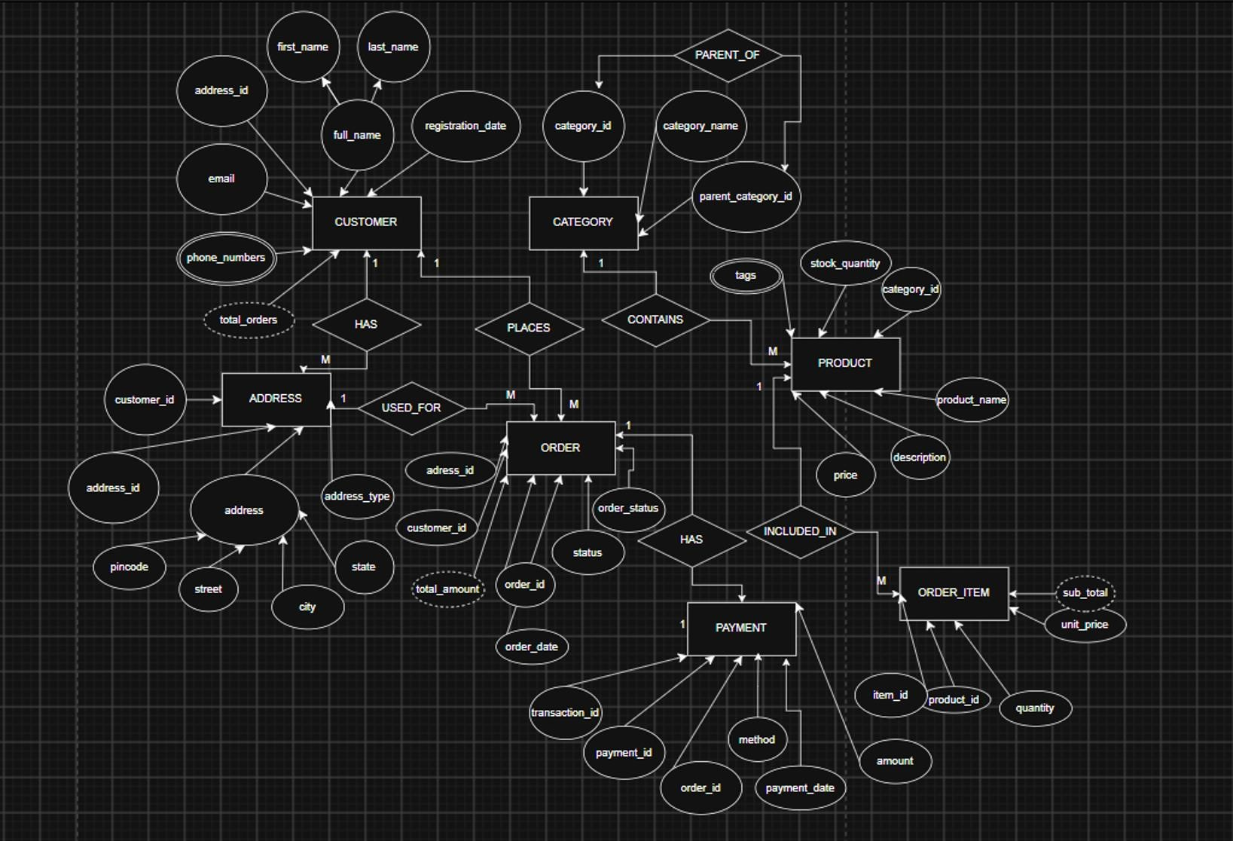

6.4 Relationships & Cardinality:
Entity 1 | Relationship | Entity 2 | Cardinality (1:1 / 1:N / M:N)
Customer | has | Address | 1 : N
Customer | places | Orders | 1 : N
Address | Is used for | Orders | 1:N
Category | Contains | Product | 1:N
Orders | Contains | Order_Item | 1:N
Product | Appears in | Order_Item | 1:N
Entity 1 | Relationship | Entity 2 | Cardinality (1:1 / 1:N / M:N)
Orders | has | Payment | 1:N
Category | Has parent category | Category | 1:N

6.5 Relational Database Schema
List every table, its columns, data types, and identify PK/FK columns.
Table Name | Column Name | Data Type |  | PK/FK/— | Constraints
Customer | customer_id | INT | PK |  | AUTO_INCREMENT, NOT NULL
Customer | first_name | VARCHAR(50) | — |  | NOT NULL
Customer | last_name | VARCHAR(50) | — |  | NOT NULL
Customer | email | VARCHAR(100) | — |  | NOT NULL, UNIQUE
Customer | phone_numbers | TEXT | — |  | —
Customer | registration_date | DATE | — |  | DEFAULT  CURRENT_DATE
Customer | total_orders | INT | — |  | Derived
Address | address_id | INT | PK |  | AUTO_INCREMENT, NOT NULL
Address | customer_id | INT | FK |  | REFERENCES  Customer(customer_id)
Address | street | VARCHAR(200) | — |  | NOT NULL
Address | city | VARCHAR(100) | — |  | NOT NULL
Address | state | VARCHAR(100) | — |  | NOT NULL
Address | pincode | VARCHAR(10) | — |  | NOT NULL
Address | address_type | VARCHAR(20) | — |  | —
Category | category_id | INT | PK |  | AUTO_INCREMENT, NOT NULL
Category | category_name | VARCHAR(100) | — |  | NOT NULL, UNIQUE
Category | parent_category_id | INT | FK |  | REFERENCES  Category(category_id)
Product | product_id | INT | PK |  | AUTO_INCREMENT, NOT NULL
Product | product_name | VARCHAR(200) | — |  | NOT NULL
Product | description | TEXT | — |  | —
Product | price | DECIMAL(10,2) | — |  | NOT NULL, CHECK  (price >= 0)
Product | stock_quantity | INT | — |  | —

Table Name | Column Name | Data Type |  | PK/FK/— | Constraints
Product | category_id | INT | FK |  | REFERENCES  Category(category_id)
Product | tags | TEXT | — |  | —
Orders | order_id | INT | PK |  | AUTO_INCREMENT, NOT NULL
Orders | customer_id | INT | FK |  | REFERENCES  Customer(customer_id)
Orders | address_id | INT | FK |  | REFERENCES  Address(address_id)
Orders | order_date | DATE | — |  | —
Orders | Order_status | VARCHAR(30) | — |  | DEFAULT 'Pending'
Orders | Total_amount | DECIMAL(10,2) | — |  | Derived
Order_item | Item_id | INT | PK |  | AUTO_INCREMENT, NOT NULL
Order_item | Order_id | INT | FK |  | REFERENCES  Orders(order_id)
Order_item | Product_id | INT | FK |  | REFERENCES  Product(product_id)
Order_item | Quantity | INT | __ |  | NOT NULL, CHECK  (quantity > 0)
Order_item | Unit_price | DECIMAL(10,2) | __ |  | __
Order_item | Subtotal | DECIMAL(10,2) | __ |  | Derived
Payment | Payment_id | INT | PK |  | AUTO_INCREMENT, NOT NULL
Payment | Order_id | INT | FK |  | REFERENCES  Orders(order_id)
Payment | Payment_date | DATE | __ |  | __
Payment | Amount | DECIMAL(10,2) | __ |  | __
Payment | Method | VARCHAR(30) | __ |  | __
Payment | Status | VARCHAR(20) | __ |  | DEFAULT 'Pending'
Payment | Transaction_id | VARCHAR(100) | __ |  | UNIQUE

6.6 Normalization
1NF: Multi-valued phone attributes are extracted into a separate table, and product tagging terms are handled atomically so that every table cell contains only an atomic value.
2NF: The system meets 1NF and isolates composite values. The Order_Item junction table separates item purchase counts from top-level order records, ensuring non-prime fields depend entirely on the complete primary keys.
3NF: Transitive vulnerabilities are removed. The transaction unit_price is explicitly archived inside Order_Item (instead of pulling live from Product.price) to preserve historical financial totals against future catalog shifts. Derived calculations like order total_amount and line subtotal are handled via views.

7. DATABASE IMPLEMENTATION

7.1 DDL — Database and Table Creation
Paste CREATE DATABASE / CREATE TABLE statements and include constraints such as NOT NULL, UNIQUE, CHECK, DEFAULT, PRIMARY KEY, and FOREIGN KEY.
CREATE TABLE Customer (
customer_id INT GENERATED ALWAYS AS IDENTITY PRIMARY KEY,
first_name VARCHAR(50) NOT NULL, last_name VARCHAR(50) NOT NULL, email VARCHAR(100) UNIQUE NOT NULL, registration_date DATE DEFAULT CURRENT_DATE
);
CREATE TABLE Address (
address_ id INT GENERATED ALWAYS AS IDENTITY PRIMARY KEY,
customer_ id INT NOT NULL, street VARCHAR (200),
city VARCHAR(100),
state VARCHAR(100), pincode VARCHAR(10),
address_ type VARCHAR(20) DEFAULT 'Home',
FOREIGN KEY (customer_id)
REFERENCES Customer(customer_id)
);
CREATE TABLE Category (
category_id INT GENERATED ALWAYS AS IDENTITY PRIMARY KEY,
category_name VARCHAR(100) NOT NULL UNIQUE,
parent_category_id INT,
FOREIGN KEY (parent_category_id) REFERENCES Category(category_id)
);
CREATE TABLE Product (
product_id INT GENERATED ALWAYS AS IDENTITY PRIMARY KEY, product_name VARCHAR(200) NOT NULL,
description TEXT,
price DECIMAL(10,2) NOT NULL CHECK (price >= 0), stock_quantity INT DEFAULT 0, category_id INT,
FOREIGN KEY (category_id) REFERENCES Category(category_id)
);
CREATE TABLE Orders (
order_id INT GENERATED ALWAYS AS IDENTITY PRIMARY KEY,
customer_id INT NOT NULL, address_id INT,
order_date DATE DEFAULT CURRENT_DATE, order_status VARCHAR(30) DEFAULT 'Pending',
FOREIGN KEY (customer_id) REFERENCES Customer(customer_id),
FOREIGN KEY (address_id) REFERENCES Address(address_id)
);
CREATE TABLE Order_Item (
item_id INT GENERATED ALWAYS AS IDENTITY PRIMARY KEY,
order_id INT NOT NULL, product_id INT NOT NULL, quantity INT NOT NULL CHECK (quantity > 0), unit_price DECIMAL(10,2) NOT NULL,
FOREIGN KEY (order_id) REFERENCES Orders(order_id),
FOREIGN KEY (product_id) REFERENCES Product(product_id)
);
CREATE TABLE Payment (
payment_id INT GENERATED ALWAYS AS IDENTITY PRIMARY KEY,
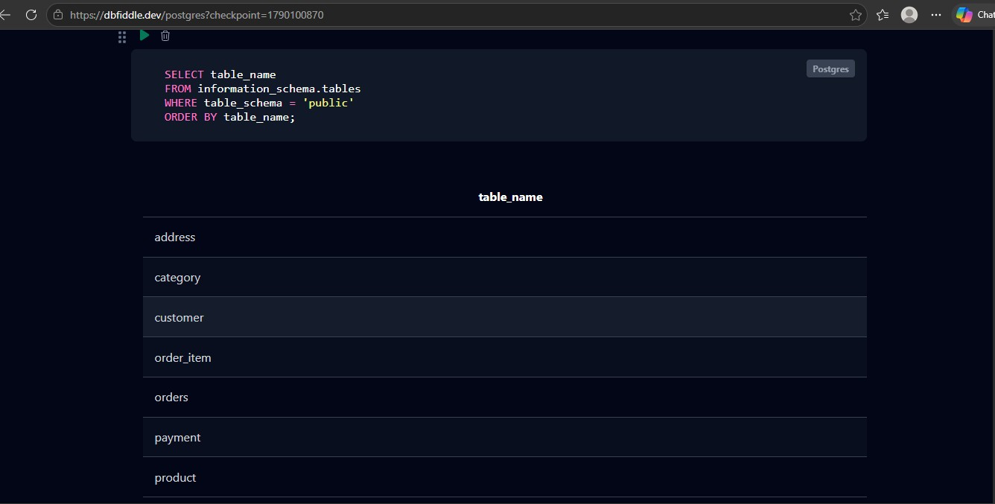

order_id INT UNIQUE NOT NULL,

payment_date DATE,

amount DECIMAL(10,2),

method VARCHAR(30),

status VARCHAR(20) DEFAULT 'Pending',

transaction_id VARCHAR(100) UNIQUE,

FOREIGN KEY (order_id) REFERENCES Orders(order_id)

)
;

7.2 Sample Data — DML
Insert sufficient sample data into all tables. Include INSERT, UPDATE, and DELETE examples where applicable.
Table | No. of Records | Sample Data / Screenshot Reference
Customer | 3 | 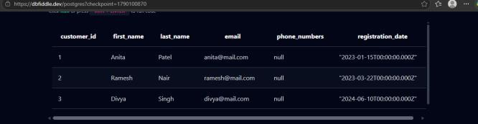

Table | No. of Records | Sample Data / Screenshot Reference
Address | 3 | 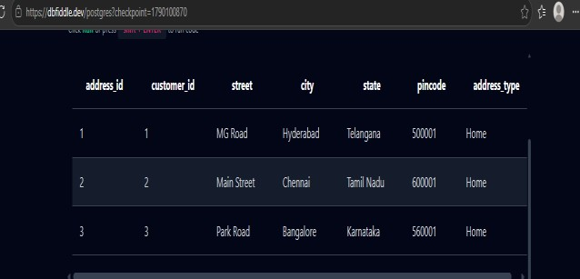
Category | 3 | 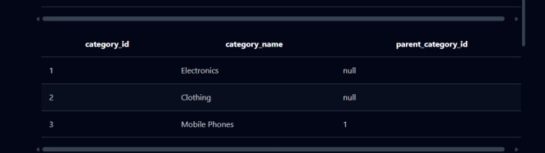
Product | 3 | 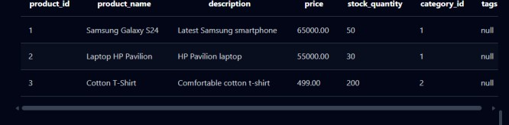
Order | 3 | 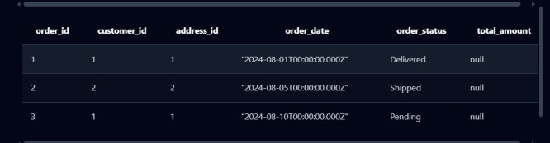
Order_Item | 3 | 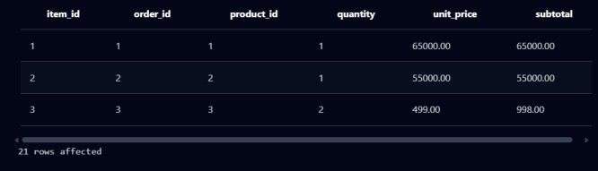
Payment | 3 | 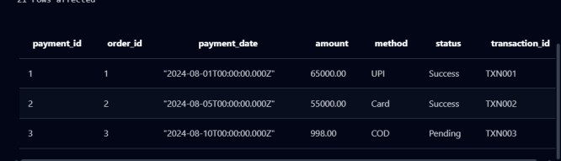
INSERT  OPERATION | __ | 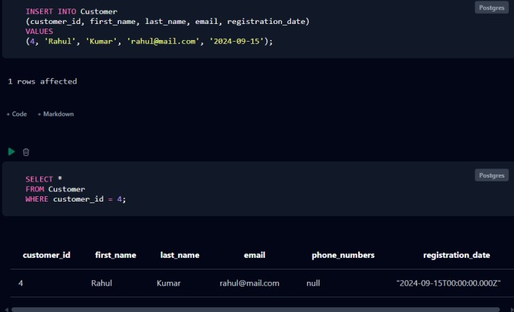
Table | No. of Records | Sample Data / Screenshot Reference
UPDATE  OPERATION | __ | 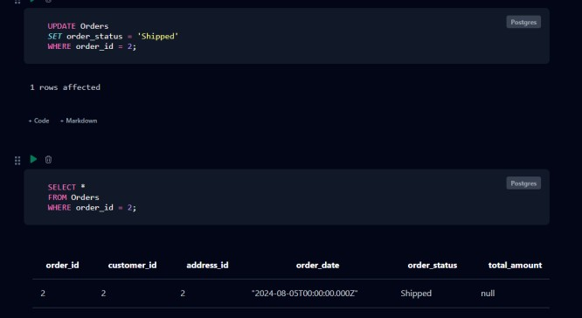
DELETE  OPERATION | __ | 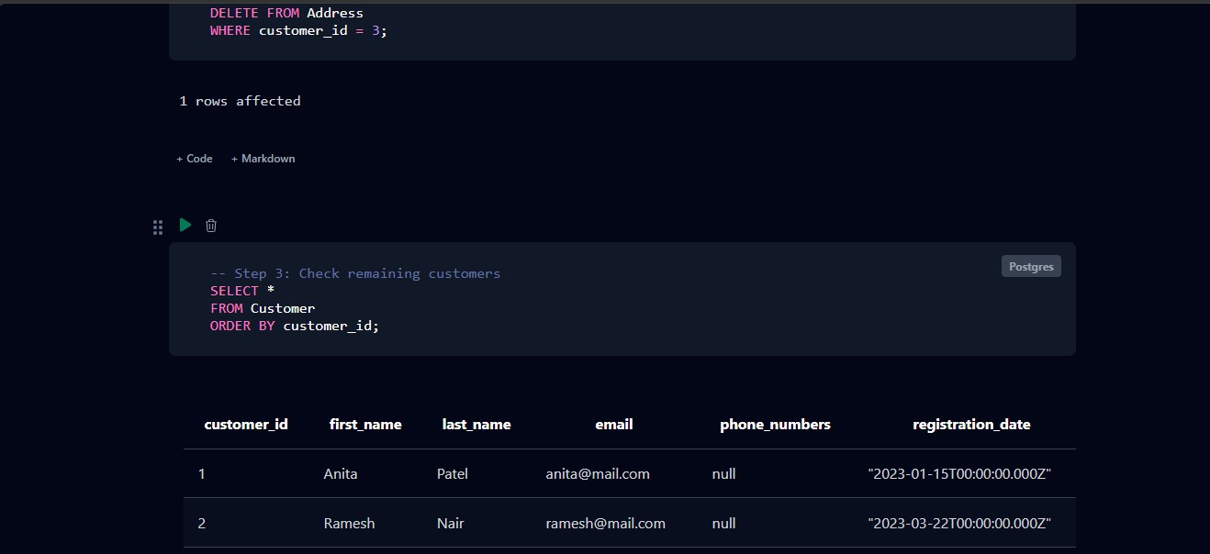

7.3 Constraints & Data Integrity
List the constraints and validations applied to keep the data accurate and consistent (no duplicate IDs, valid values, referential integrity).
Constraint / Validation | Applied On | Purpose | Evidence / Screenshot
PRIMARY KEY | All main tables | Uniquely identifies records | Verified via relationship constraints in Section 7.1 DDL script.
FOREIGN KEY | Address, Category,  Product, Orders,  Order_Item, Payment | Maintains referential integrity | Enforced automatically during data creation across rows.
NOT NULL | Customer, Product, Order_Item etc. | Prevents mandatory fields from being empty | Enforced through structural indices in the relational database.
UNIQUE | Customer.email,  Payment.transaction_id | Prevents duplicate values | Enforced through structural indices in the relational database.
CHECK | Product.price,  Order_Item.quantity | Ensures valid ranges | Price >= 0 and quantity > 0 range rules validated cleanly.
DEFAULT | Dates/status fields | Supplies default values | CURRENT_DATE applied on dates and 'Pending' on status tags.

7.4 SQL Operations & Queries
Include representative examples of DDL, DML, DQL, CRUD, Joins, Aggregate Functions, GROUP BY / HAVING, Subqueries, Views, and other relevant queries.
S.No | Operation / Query | Purpose | SQL Query / Screenshot Ref.
1 | DDL-Create Database | Creates the project database. | CREATE DATABASE  ECommerce_Order_Management;
2 | DDL-Create Table | Creates tables with required constraints. | CREATE TABLE Customer (...);
3 | DML-INSERT | Adds new customer records. | INSERT INTO Customer  (first_name, last_name, email)  VALUES  ('Anita','Patel','anita@mail.com');
4 | DML-UPDATE | Updates an existing order status. | UPDATE Orders SET order_status='Shipped' WHERE order_id=2;
5 | DML-DELETE | Deletes a customer record. | DELETE FROM Customer WHERE customer_id=3;
6 | DQL-SELECT | Displays all customer records. | SELECT * FROM Customer;
7 | CRUD-CREATE | Creates a new customer record. | INSERT INTO Customer  (first_name,last_name,email)
S.No | Operation / Query | Purpose | SQL Query / Screenshot Ref.
VALUES
('Rahul','Kumar','rahul@mail.com');
8 | CRUD-READ | Reads customer information. | SELECT * FROM Customer;
9 | CRUD-UPDATE | Modifies order information. | UPDATE Orders SET order_status='Shipped' WHERE order_id=2;
10 | CRUD-DELETE | Removes a customer record. | DELETE FROM Customer WHERE customer_id=3;
11 | JOIN | Displays customers with their orders. | SELECT c.first_name, o.order_id, o.order_status FROM Customer c  JOIN Orders o ON  c.customer_id=o.customer_id;
12 | Aggregate Function | Counts the number of orders for each customer. | SELECT customer_id, COUNT(*)  AS total_orders FROM Orders  GROUP BY customer_id;
13 | GROUP BY | Groups orders according to customer. | SELECT customer_id, COUNT(*)  AS total_orders FROM Orders  GROUP BY customer_id;
14 | Flitering | Displays products costing more than 1000. | SELECT product_name, price FROM Product WHERE price > 1000;
15 | Sorting | Displays products above 1000 in descending price order. | SELECT product_name, price FROM  Product WHERE price > 1000  ORDER BY price DESC;
16 | VIEW | Creates a view containing order details. | CREATE VIEW Order_Details AS  SELECT o.order_id, c.first_name,  o.order_date, o.order_status FROM Orders o JOIN Customer c ON o.customer_id=c.customer_id;

127.5 Sample Outputs / Screenshots
Paste important execution screenshots with a short caption. Screenshots should clearly show the query and its output.
Figure 1: Tables

Figure 2: Join Querey

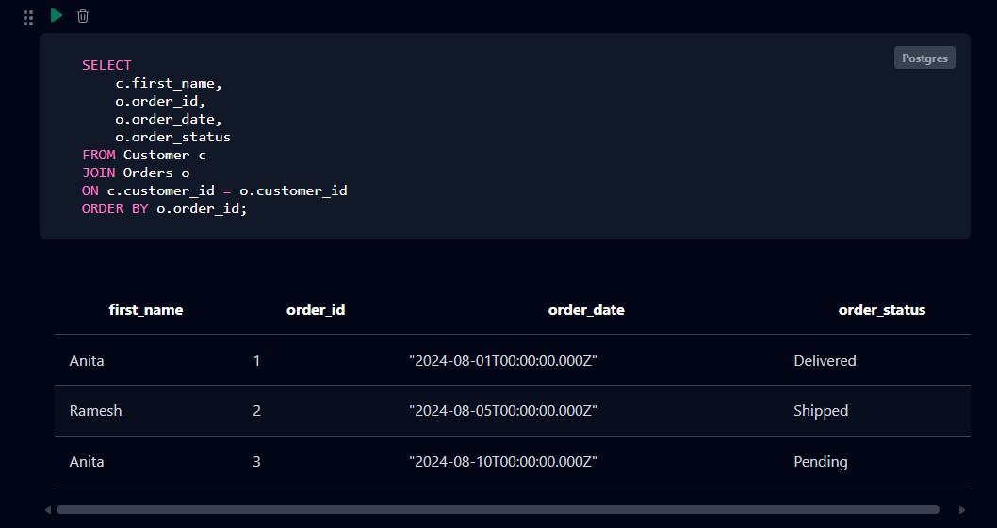

Figure 3: Aggregate function

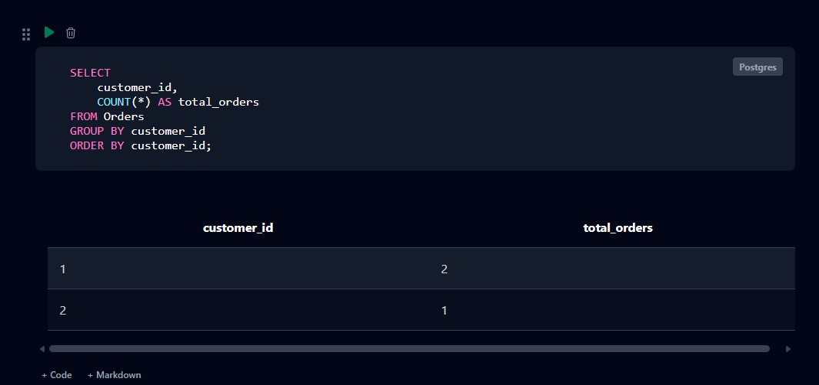

Figure 4: Delete operation

- MODULES & FUNCTIONALITIES
Explain the major modules/features of the system and what each module does.
S.No | Module Name | Functionality
1 | Customer Management | Stores and manages customer information such as name, email, phone number, and registration date.
2 | Address Management | Stores customer addresses including street, city, state, pincode, and address type.
3 | Category Management | Maintains product categories and supports parent-child category relationships.
4 | Product Management | Stores product details such as product name, description, price, stock quantity, category, and tags.
5 | Order Management | Creates and manages customer orders, including order date, status, customer, and delivery address.
6 | Order Item Management | Maintains individual products included in an order, including quantity, unit price, and subtotal.
7 | Payment Management | Stores payment details such as payment date, amount, payment method, status, and transaction ID.
8 | CRUD Operations | Supports Create, Read, Update, and Delete operations for managing database records.
9 | SQL Query & Reporting | Retrieves and analyzes data using filtering, sorting, joins, aggregate functions, and views.
10 | Data Validation & Integrity | Maintains accurate and consistent data using PK, FK, NOT NULL, UNIQUE, CHECK, and DEFAULT constraints.

- GITHUB REPOSITORY & TEAM RESPONSIBILITIES
Provide the repository link and clearly mention each team member's contribution.
Repository Link:

Student Name | Roll Number | Role / Responsibility | Contribution Status
G.SPANDANA | 25B11AI340 | ER Diagram, Database Design,  Table Creation, PPT Preparation  & GitHub Management | Completed
N.SITA MAHALAKSHMI | 25B11AI845 | SQL Queries, CRUD Operations & Data Manipulation | Completed
K.PAVANI | 25B11AID17 | Sample Data Insertion, Query Testing & Validation | Completed
Student Name | Roll Number | Role / Responsibility | Contribution Status
P.RISHITHA | 25B11AI940 | Project Documentation & Presentation Support | Completed

- ENHANCEMENTS & FUTURE IMPROVEMENTS
Mention planned or implemented enhancements such as additional modules, security, performance improvements, reporting, UI integration, or scalability.
The following enhancements are planned for future implementation to extend the database architecture:
- Order Tracking: Add a specialized shipment tracking module to monitor delivery vehicle routes and automated milestone updates.
- Advanced Reporting: Implement daily database reporting protocols to extract localized charts for sales, orders, and payment methods.
- Business Analytics: Embed database store procedures to capture long-term retail trends and calculate seasonal user spending.
- Workflow Automation: Integrate automated triggers to systematically update backend stock totals whenever a checkout order goes live.
- Scalability Adjustments: Configure secondary database indexes on frequently queried email and date field columns to accelerate searching speeds.

- CONCLUSION
The E-Commerce Order Management System successfully demonstrates a structured and relational approach to managing online shopping transactional data assets. The developed database architecture securely models core domain entities, including customers, multi-destination delivery addresses, hierarchical product categories, catalog items, customer checkouts, granular order line breakdowns, and payment settlements.
Explicit primary key configurations and relational foreign key connections establish secure linkages across all tables, while database normalization up to the Third Normal Form (3NF) completely eliminates data redundancy and shields the storage layer from update, insertion, or deletion anomalies. Strict validation parameters—including NOT NULL, UNIQUE, and CHECK constraints—guarantee data integrity from the moment a product checkout is initialized to its final gateway payment completion.
Through the execution of automated table layouts, mock data inserts, and multi-table DQL operations (JOINs, summary aggregations, and database views) within the relational database interface engine, this project demonstrates how a centralized system optimizes data consistency, storage organization, and retrieval efficiency for modern digital marketplace configurations.

- REFERENCES
List textbooks, articles, documentation, websites, or other resources referred to during the project.
1. Elmasri, R. and Navathe, S. B., Fundamentals of Database Systems, 7th Edition, Pearson Education.
2. Silberschatz, A., Korth, H. F., and Sudarshan, S., Database System Concepts, McGraw-Hill.
3. PostgreSQL Global Development Group, PostgreSQL 16 Core Language SQL Reference Documentation.
4. Department Course Notes and Laboratory Implementation Manuals on Database Management Systems, Aditya University.
5. W3Schools & GeeksforGeeks, Online SQL Programming and Relational Design Resource Materials.
6. Project database scripts, interactive view setups, and source configuration deployment files hosted completely via GitHub repository.
APPENDIX

A. Complete SQL Script
-- 1. DATA DEFINITION LANGUAGE (DDL) - TABLE STRUCTURES
CREATE TABLE Customer (
customer_id INT PRIMARY KEY AUTO_INCREMENT,
first_name VARCHAR(50) NOT NULL,
last_name VARCHAR(50) NOT NULL,
email VARCHAR(100) UNIQUE NOT NULL,
registration_date DATE DEFAULT (CURRENT_DATE)
);

CREATE TABLE Address (
address_id INT PRIMARY KEY AUTO_INCREMENT,
customer_id INT NOT NULL,
street VARCHAR(200),
city VARCHAR(100),
state VARCHAR(100),
pincode VARCHAR(10),
address_type VARCHAR(20) DEFAULT "Home",
FOREIGN KEY (customer_id) REFERENCES Customer(customer_id)
);

CREATE TABLE Category (
category_id INT PRIMARY KEY AUTO_INCREMENT,
category_name VARCHAR(100) NOT NULL UNIQUE,
parent_category_id INT,
FOREIGN KEY (parent_category_id) REFERENCES Category(category_id)
);

CREATE TABLE Product (
product_id INT PRIMARY KEY AUTO_INCREMENT,
product_name VARCHAR(200) NOT NULL,
description TEXT,
price DECIMAL(10,2) NOT NULL CHECK (price >= 0),
stock_quantity INT DEFAULT 0,
category_id INT,
FOREIGN KEY (category_id) REFERENCES Category(category_id)
);

CREATE TABLE Orders (
order_id INT PRIMARY KEY AUTO_INCREMENT,
customer_id INT NOT NULL,
address_id INT,
order_date DATE DEFAULT (CURRENT_DATE),
order_status VARCHAR(30) DEFAULT "Pending",
FOREIGN KEY (customer_id) REFERENCES Customer(customer_id),
FOREIGN KEY (address_id) REFERENCES Address(address_id)
);

CREATE TABLE Order_Item (
item_id INT PRIMARY KEY AUTO_INCREMENT,
order_id INT NOT NULL,
product_id INT NOT NULL,
quantity INT NOT NULL CHECK (quantity > 0),
unit_price DECIMAL(10,2) NOT NULL,
FOREIGN KEY (order_id) REFERENCES Orders(order_id),
FOREIGN KEY (product_id) REFERENCES Product(product_id)
);

CREATE TABLE Payment (
payment_id INT PRIMARY KEY AUTO_INCREMENT,
order_id INT UNIQUE NOT NULL,
payment_date DATE,
amount DECIMAL(10,2),
method VARCHAR(30),
status VARCHAR(20) DEFAULT "Pending",
transaction_id VARCHAR(100) UNIQUE,
FOREIGN KEY (order_id) REFERENCES Orders(order_id)
);

-- 2. DATA MANIPULATION & QUERY PARADIGMS (DML & DQL)
-- Seed Insert Lines
INSERT INTO Customer (first_name, last_name, email) VALUES ('Anita', 'Patel', 'anita@mail.com');
INSERT INTO Product (product_name, price, stock_quantity, category_id) VALUES ('Samsung Galaxy S24', 65000.00, 50, 1);

-- Modification Control
UPDATE Orders SET order_status = 'Shipped' WHERE order_id = 2;

-- Analytical Operations (Joins, Groups & Views)
SELECT c.first_name, c.last_name, o.order_id FROM Customer c JOIN Orders o ON c.customer_id = o.customer_id;
SELECT customer_id, COUNT(*) AS total_orders FROM Orders GROUP BY customer_id;

CREATE VIEW Order_Details AS
SELECT o.order_id, c.first_name, o.order_date, o.order_status FROM Orders o JOIN Customer c ON o.customer_id = c.customer_id;

B. Additional Screenshots / Outputs
Tables created successfully
Sample data
Important SQL queries
Query outputs/results

